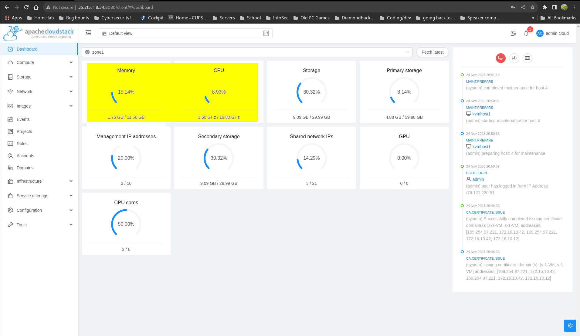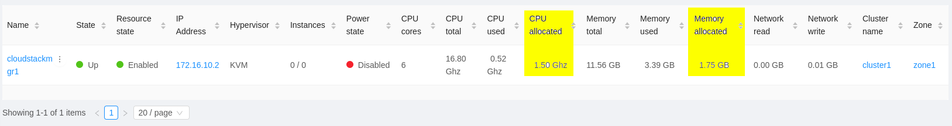**Below is the CPU/RAM allocation from the dashboard and then from metrics view after kvmhost1 was removed from hosts:**

**Below is a screenshot of CPU/Memory allocation from the dashboard and metrics view page after kvmhost1 was added back as a host:**

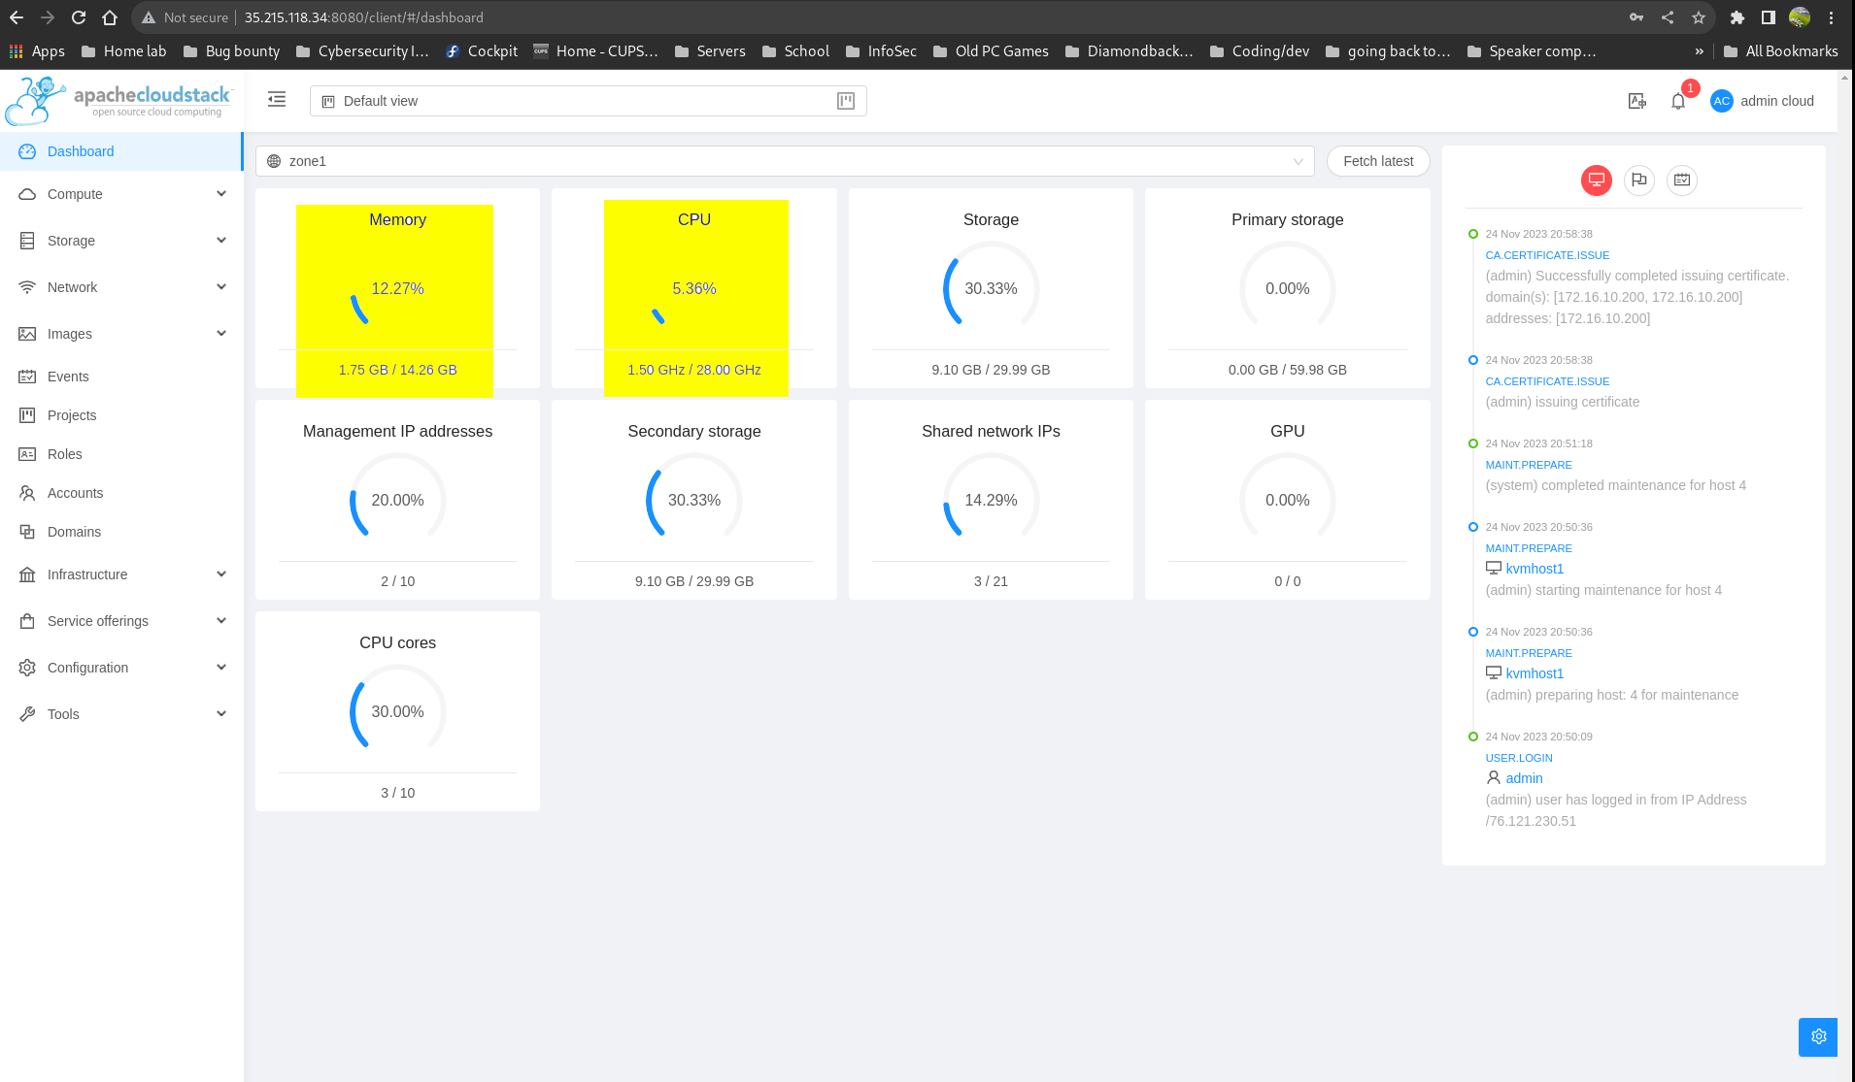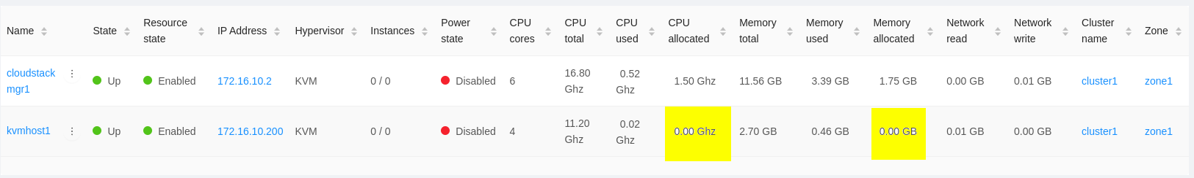

**Below you can see that the admin view of the newly create instance tells us which host the instance is allocated on:**

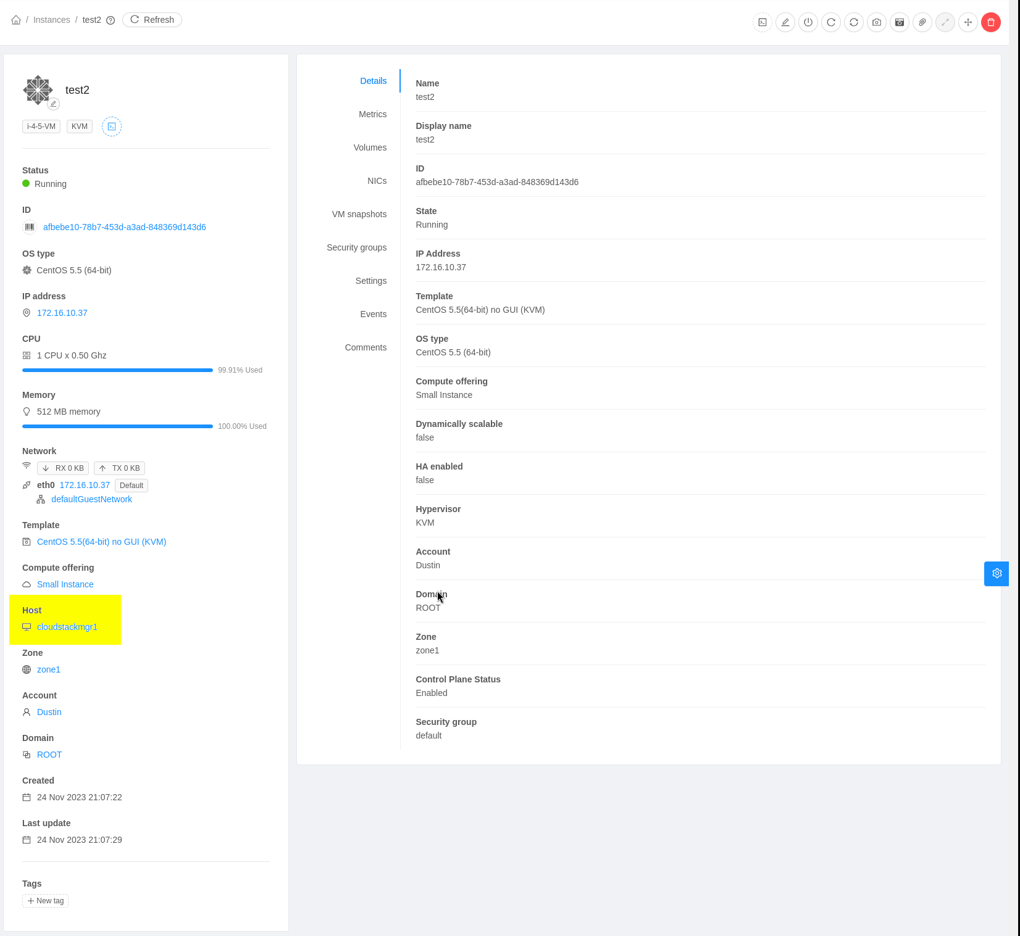

**Below you can see the additionally allocated CPU/Memory on cloudstackmgr1:**

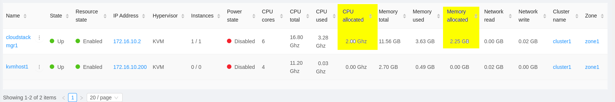

**Here are screenshots from the dashboard and host metrics pages after adding my 3rd host to my new domain:**

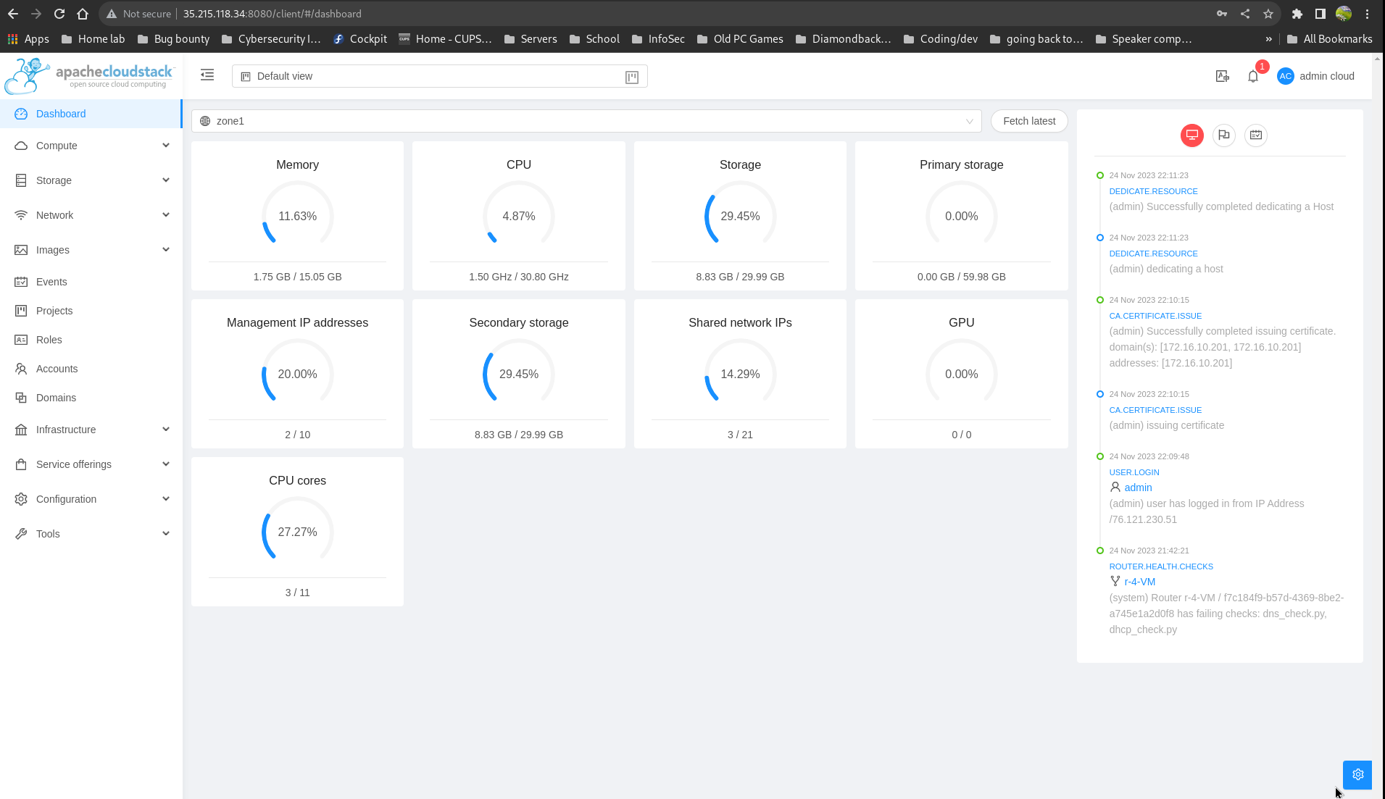

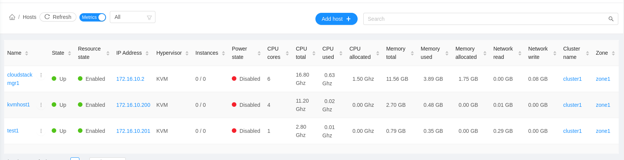

**This is thescreenshot of the newly created instance and its domain (kvmhsto1), but I honestly am drawing a blank on why it would assign to kvmhost1 now instead of cloudstacmkgr1:**

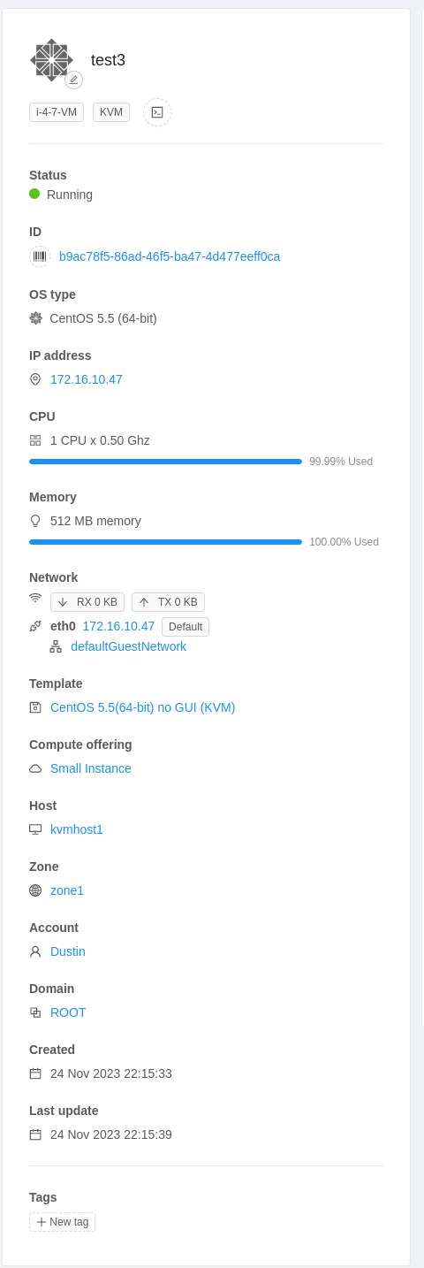

**So, when I added a new instance under my Domain Admin account, it was created on the newly added host called test1. In the steps of this lab where we created a new domain (mine is called LaLaLand), added a new host, and associated that domain with the new host I actually created a whole new instance/domain from outernetwork1 using qemu and virsh, set up cloudstack agent on that domain, added it in the CloudStack Manager UI, and then associated it with the domain I created in the UI; if we were supposed to do this differently it did not come across to me that way in the instructions. Regardless, it worked the way I did it too; just my new instance created from the Domain Admin account did not host itself on kvmhost1:**

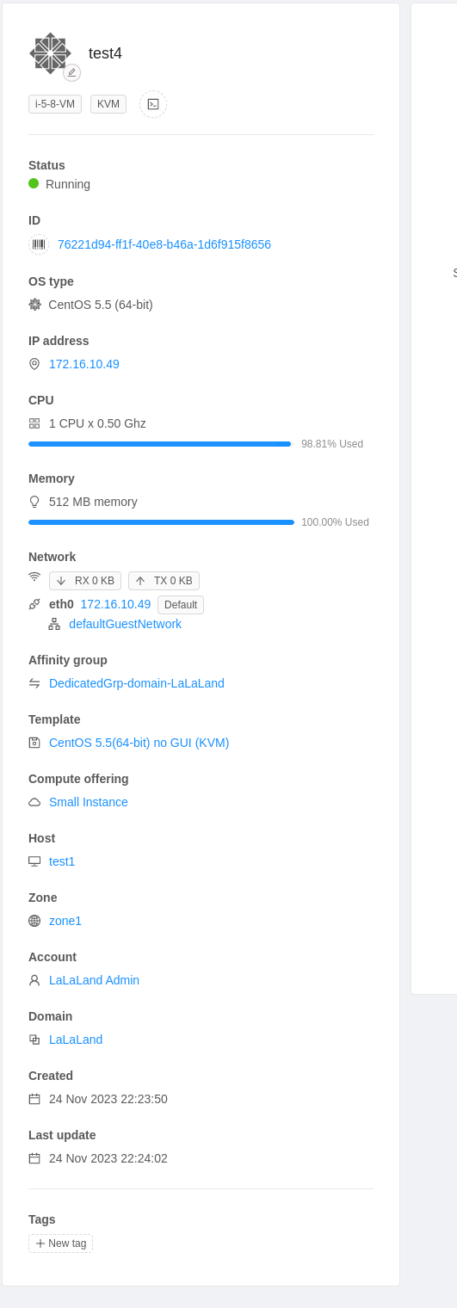

**As you can see below, logged in as the user “dustin” I cannot see the VM test4 that I created under the domain account; nor can I see the affinity group associated with my newly created domain:**

